Ideation Phase
Brainstorm & Idea Prioritization
Date | 24 September 2026
Team ID | SWTID-2026-7356
Project Name | AI StudyBuddy
Maximum Marks | 4 Marks

Brainstorm & Idea Prioritization
AI StudyBuddy is a Node.js, Express and MongoDB backend that uses Google Gemini 2.5 Flash to help students prepare for exams. During brainstorming the team listed the problems students face, such as lengthy notes, manual flashcard making, no self-testing, no personal study plan, scattered material and unprotected personal data. Ten ideas were collected and grouped into AI-powered learning, material management, security and access, and administration. The ideas were then ranked by learning impact and effort to build. AI summary generation received the highest priority, followed by quiz generation, flashcard generation, study plan generation, material upload and storage, JWT authentication with role-based access, and admin management.

Step-1: Team Gathering, Collaboration and Select the Problem Statement
The team discussed the difficulties students face during exam preparation and agreed on one problem statement for the project.
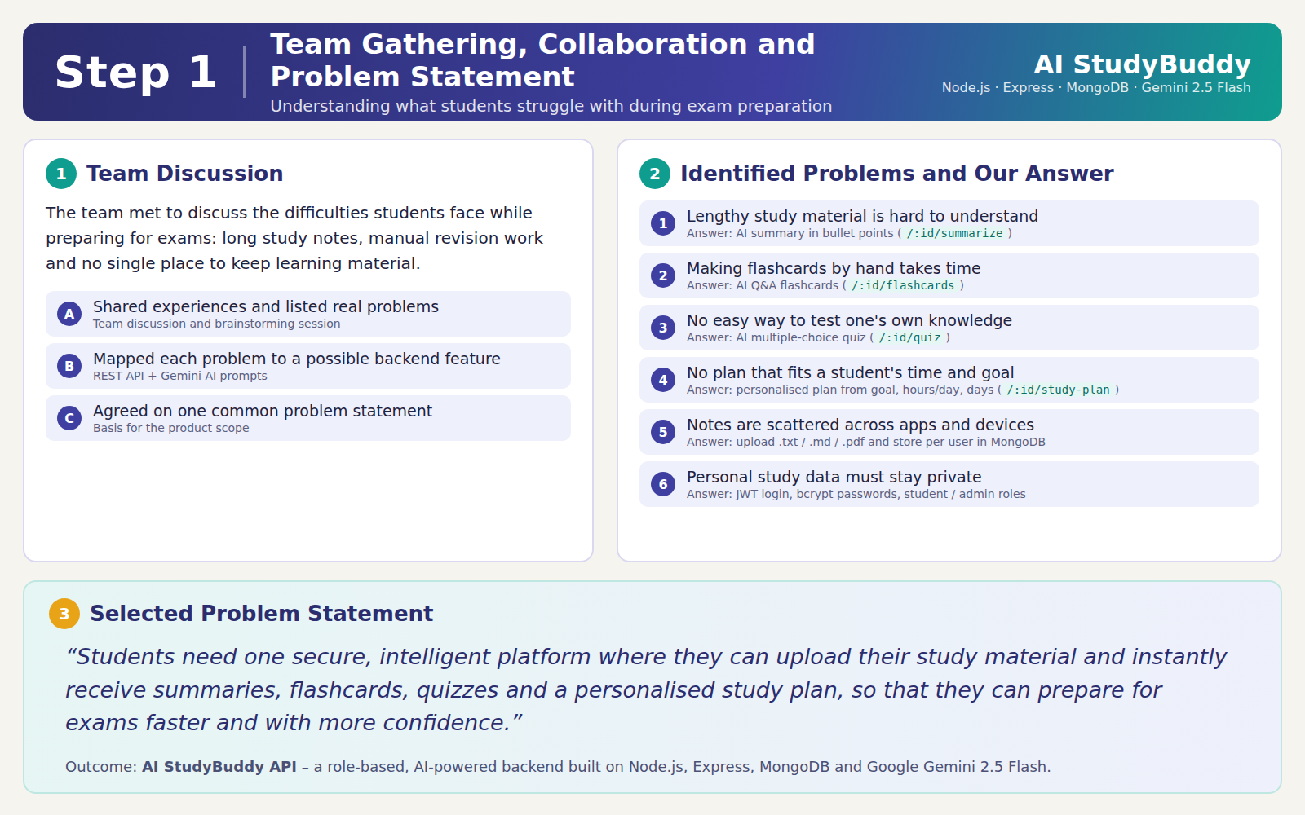

Step-2: Brainstorm, Idea Listing and Grouping
Each idea is linked to the API feature that implements it in the source code.
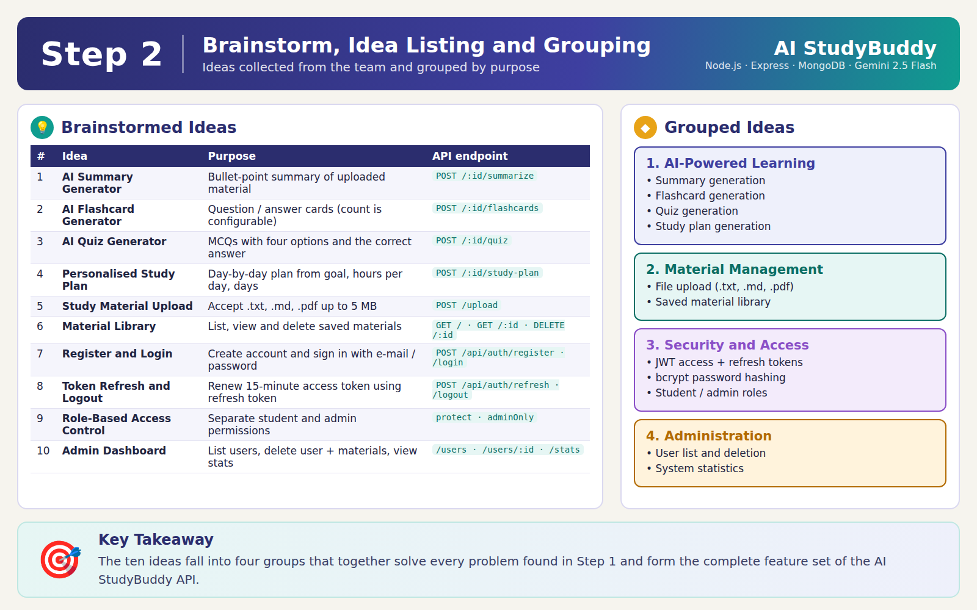

Step-3: Idea Prioritization
Ideas were scored on impact and effort and ranked, and the final solution was selected.


